Layer 1 testing
Wednesday, April 22, 2026
1:13 PM

Scenario --> ecb hikes in september 2026, and then there is a small chance of a cut after that in dec 2026. show me Z6 structures

Output -
***Outrights (default set — scenario did not specify families)***
ERZ6 97.93 c
ERZ6 97.93 p
ERZ6 98.00 c
ERZ6 97.87 p
ERZ6 98.00 p
ERZ6 98.06 c

***Vertical spreads***
ERZ6 97.93/98.00 cs
ERZ6 97.93/98.06 cs
ERZ6 97.93/97.87 ps
ERZ6 97.93/97.81 ps
ERZ6 98.00/98.06 cs
ERZ6 98.00/98.12 cs
ERZ6 98.00/97.93 ps
ERZ6 98.00/97.87 ps

***Flies (symmetric)***
ERZ6 97.87/97.93/98.00 c fly
ERZ6 97.81/97.93/98.06 c fly
ERZ6 97.93/98.00/98.06 c fly
ERZ6 97.87/98.00/98.12 c fly

***Flies (broken, in favour)***
ERZ6 97.81/97.93/98.00 c fly
ERZ6 97.75/97.93/98.00 c fly
ERZ6 97.75/97.93/98.06 c fly
ERZ6 97.87/98.00/98.06 c fly
ERZ6 97.81/98.00/98.06 c fly
ERZ6 97.81/98.00/98.12 c fly

***Flies (broken, against)***
ERZ6 97.87/97.93/98.06 c fly
ERZ6 97.87/97.93/98.12 c fly
ERZ6 97.81/97.93/98.12 c fly
ERZ6 97.93/98.00/98.12 c fly
ERZ6 97.93/98.00/98.18 c fly
ERZ6 97.87/98.00/98.18 c fly

What was the anchor chosen as here, not sure?

The ERZ6 97.93/98.00 CS does not make sense, as this structure would never be in the money with the given scenario.

The anchor for all the flies do not make sense with the given scenario.
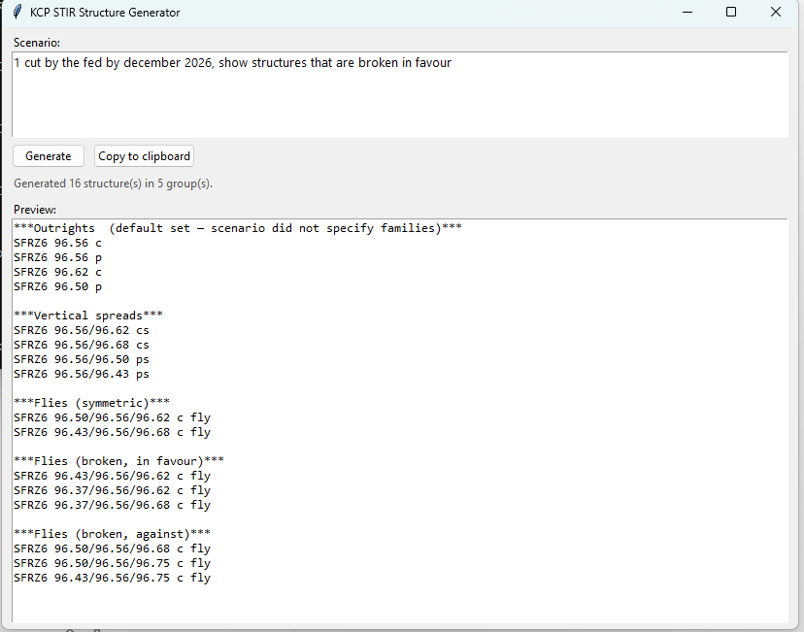

Why would you buy puts when you are looking for cuts (bullish on price)?

Where is condors?

Dec 26 means there should be options for V6 (october), X6 (november) and Z6 (december).
why was I shown structures broken against when I only asked for broken in favour?

Why only 3-4 trades per heading, the point is to generate trade possibilities and see what can be done.

Copy to clipboard button does not copy the headings

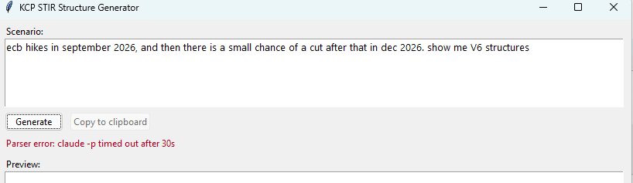

Does not show anything when I asked to show V6 structures.

Scenario --> ecb hikes in september 2026 and december 2026.

Output -
***Outrights (default set — scenario did not specify families)***
ERZ6 97.43 c
ERZ6 97.43 p
ERZ6 97.50 c
ERZ6 97.37 p

***Vertical spreads***
ERZ6 97.43/97.50 cs
ERZ6 97.43/97.56 cs
ERZ6 97.43/97.37 ps
ERZ6 97.43/97.31 ps

***Flies (symmetric)***
ERZ6 97.50/97.43/97.37 p fly
ERZ6 97.56/97.43/97.31 p fly

***Flies (broken, in favour)***
ERZ6 97.56/97.43/97.37 p fly
ERZ6 97.62/97.43/97.37 p fly
ERZ6 97.62/97.43/97.31 p fly

***Flies (broken, against)***
ERZ6 97.50/97.43/97.31 p fly

I like that you went with p flys when asked for a hike scenario.

If the target in this scenario is a fixed 97.43, why would you start the CS at 97.43. the upper strike should be 97.43 instead right.

Scenario --> the boe stays on hold through june, before cutting once in september and a small chance of cut in december

Output -
***Outrights (default set — scenario did not specify families)***
SFIZ6 96.55 c
SFIZ6 96.55 p
SFIZ6 96.60 c
SFIZ6 96.50 p
SFIZ6 96.60 p
SFIZ6 96.65 c

***Vertical spreads***
SFIZ6 96.55/96.60 cs
SFIZ6 96.55/96.65 cs
SFIZ6 96.55/96.50 ps
SFIZ6 96.55/96.45 ps
SFIZ6 96.60/96.65 cs
SFIZ6 96.60/96.70 cs
SFIZ6 96.60/96.55 ps
SFIZ6 96.60/96.50 ps

***Flies (symmetric)***
SFIZ6 96.50/96.55/96.60 c fly
SFIZ6 96.45/96.55/96.65 c fly
SFIZ6 96.55/96.60/96.65 c fly
SFIZ6 96.50/96.60/96.70 c fly

***Flies (broken, in favour)***
SFIZ6 96.45/96.55/96.60 c fly
SFIZ6 96.40/96.55/96.60 c fly
SFIZ6 96.40/96.55/96.65 c fly
SFIZ6 96.50/96.60/96.65 c fly
SFIZ6 96.45/96.60/96.65 c fly
SFIZ6 96.45/96.60/96.70 c fly

***Flies (broken, against)***
SFIZ6 96.50/96.55/96.65 c fly
SFIZ6 96.50/96.55/96.70 c fly
SFIZ6 96.45/96.55/96.70 c fly
SFIZ6 96.55/96.60/96.70 c fly
SFIZ6 96.55/96.60/96.75 c fly
SFIZ6 96.50/96.60/96.75 c fly

Same issue with the vertical spreads here as another scenario - why would you start at the target, if the scenario materializes then you end up almost ATM and making no money.

In general, I think there can be a lot more parameters that are parsed, which would make the trades generated a lot more accurate.

